Phishing Campaign Report – GoPhish
1. Introduction
This report documents the setup, execution, and results of a phishing awareness test conducted using GoPhish, Kali Linux, and Postfix.
The objective of the campaign was to simulate a realistic Google-style login phishing attempt to evaluate user behavior, detection capability, and credential-submission risk.

2. Tools & Environment
2.1 Kali Linux
Kali Linux served as the attack/control host. The system was used to:
- Run the GoPhish server
- Host the phishing landing page
- Send spoofed emails through the Postfix SMTP service
2.2 GoPhish Framework
GoPhish provided:
- Email template creation (Google Security Alert)
- Landing page cloning (Google Login Page)
- User/group management
- Campaign scheduling and tracking
- Capturing submitted credentials
2.3 Postfix Mail Server
Postfix was configured to:
- Relay outgoing phishing emails
- Pass authentication as the spoofed sender
- Log outbound mail activity for monitoring

3. Campaign Setup
3.1 Email Template
A custom email template named “google” was created, styled as:
- Sender: Google Security Team

- Subject: 2-Step Verification turned on

- Body: Notification stating 2FA had been enabled, prompting the user to verify activity

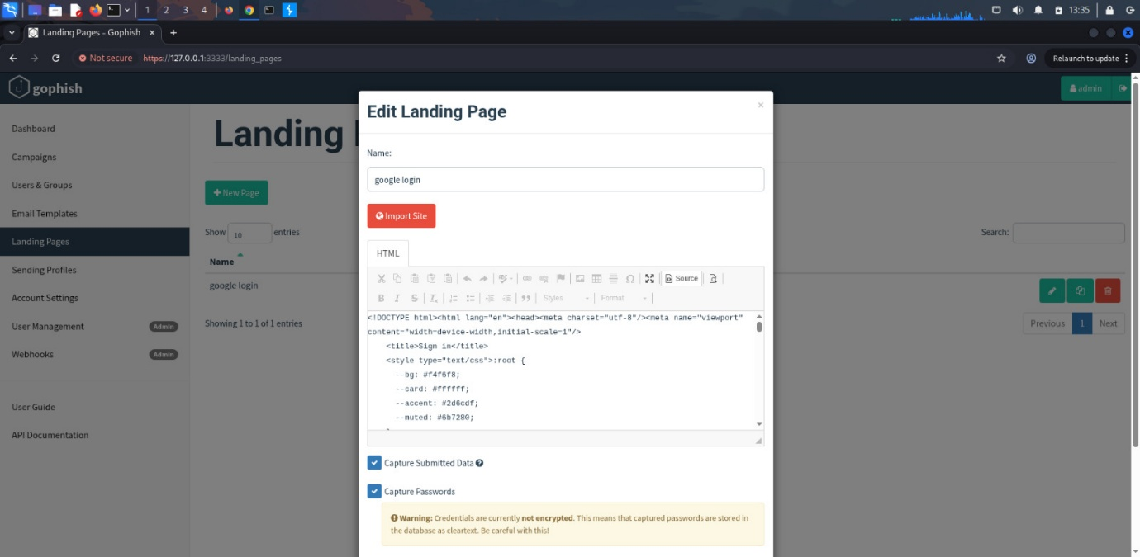
- Includes GoPhish tracking image
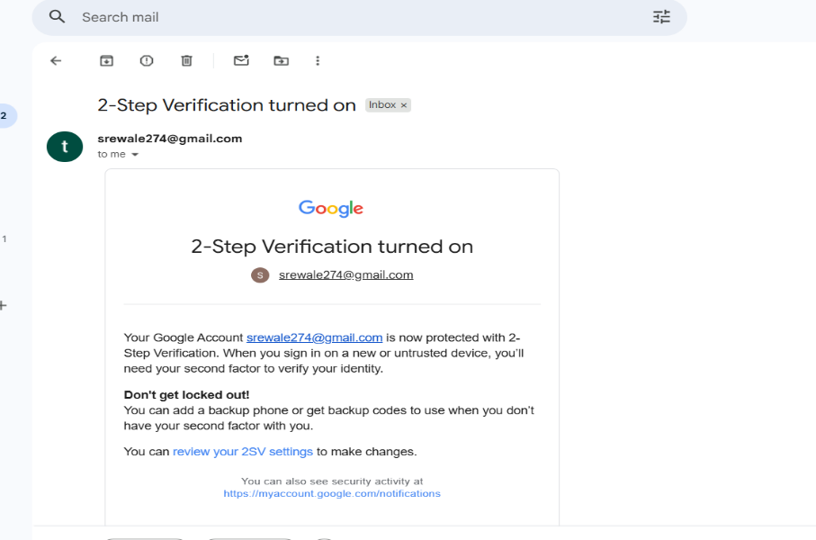

3.2 Landing Page
A cloned Google login page titled “google login” was used.
The page captured:
- Email
- Password
- “Remember me” checkbox value
Credential forwarding was enabled.
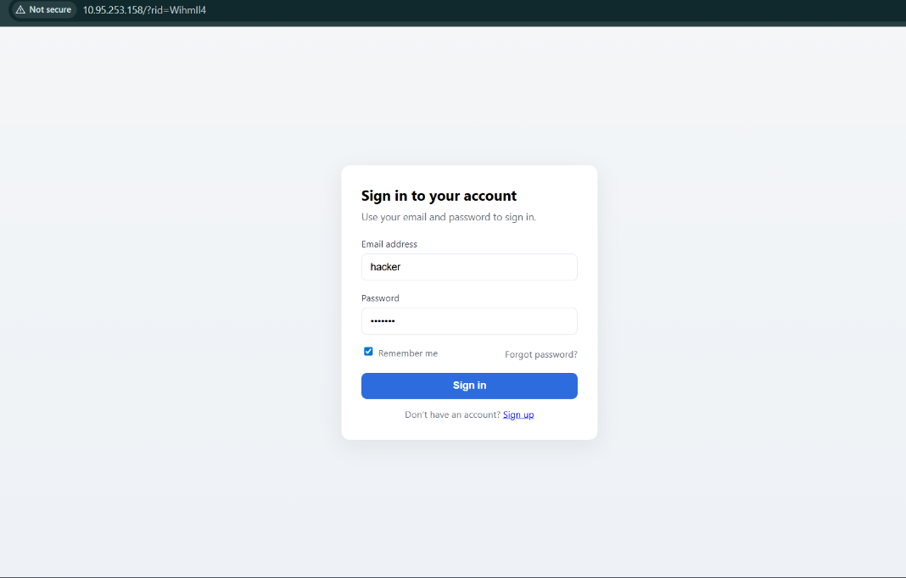

3.3 Sending Profile
A sending profile named “google login” was configured to send emails through Postfix with the spoofed Envelope Sender.

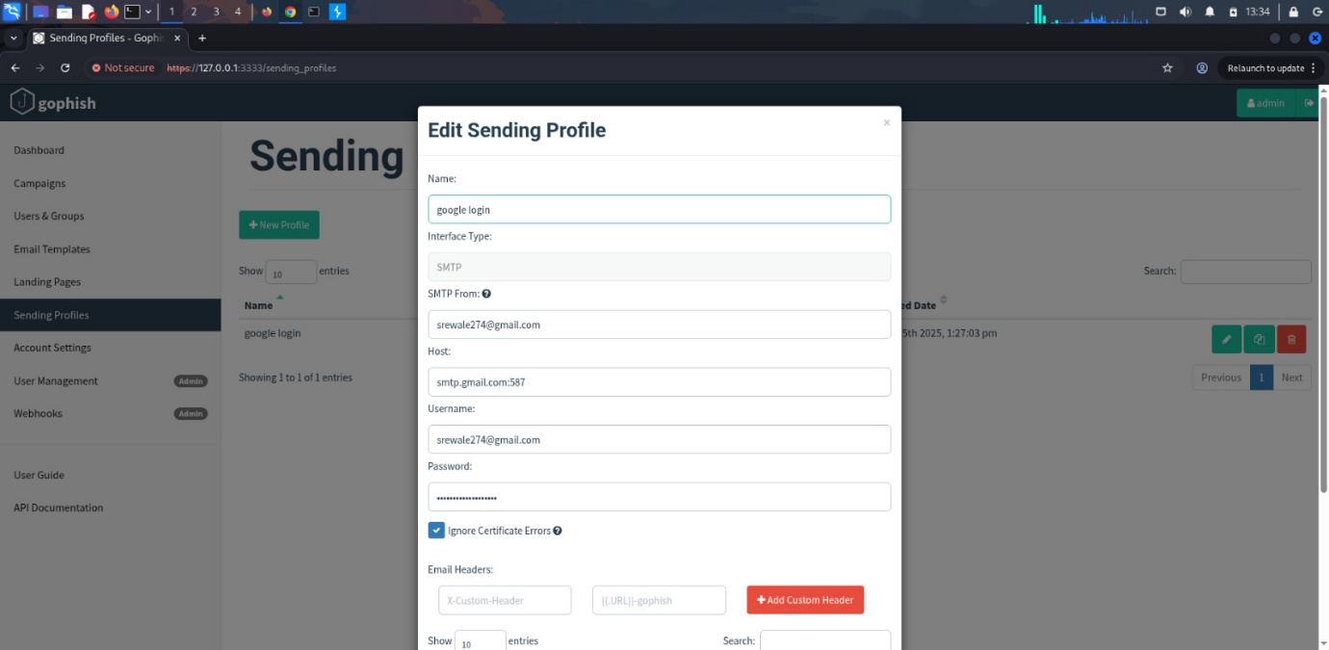

3.5 Campaign Configuration

- Name: google login campaign

- URL: http://10.95.253.158

- Group: customer

- Email Template: google

- Launch Time: November 15, 2025, 1:36 PM
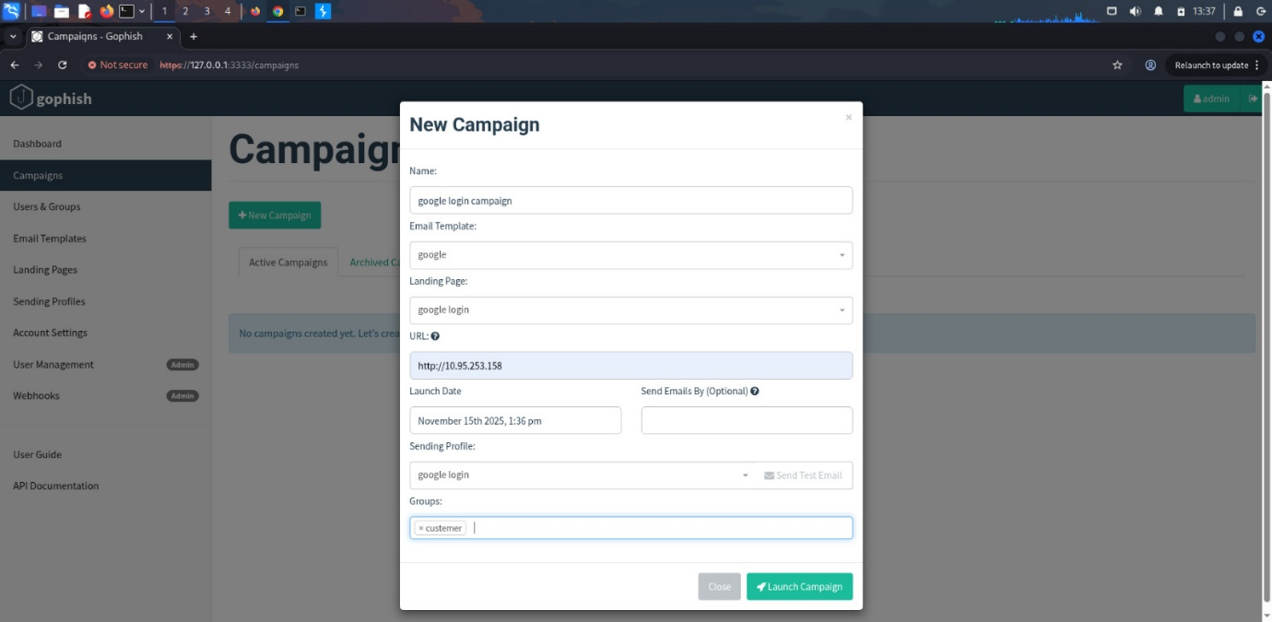

3.4 Group Creation
A user group was created to represent the phishing targets.
Group Name: customer
Target Users
First Name | Last Name | Email | Position
test | user | srewale274@gmail.com
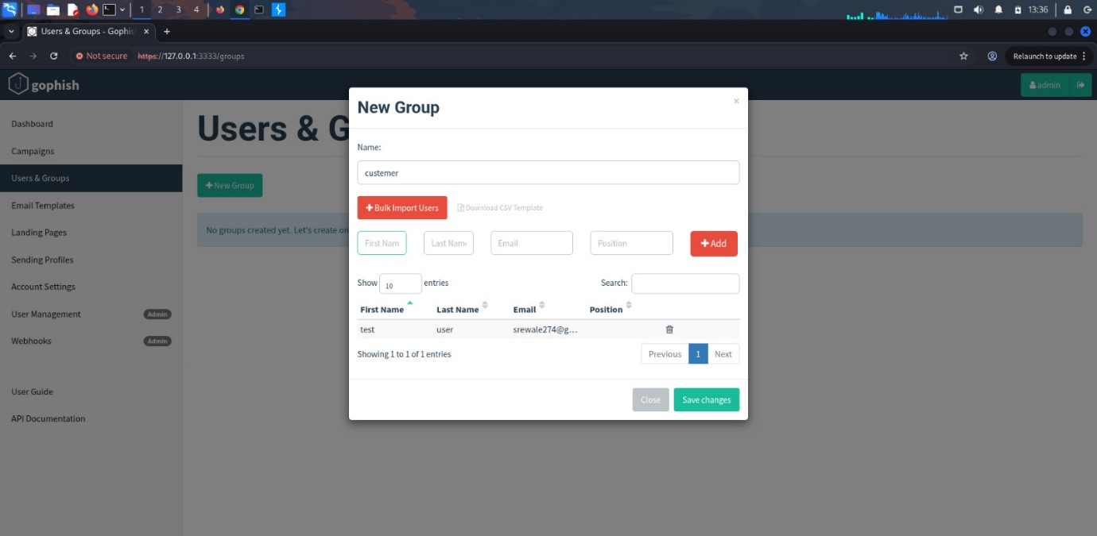

4. Campaign Execution Results
4.1 Timeline for Target
According to GoPhish logs:
Event | Time (IST) | Details
Campaign Created | Nov 15, 2025 – 1:37:35 PM | –
Email Sent | Nov 15, 2025 – 1:37:39 PM | –
Link Clicked | Nov 15, 2025 – 1:38:11 PM | Windows 10, Chrome 142
Data Submitted | Nov 15, 2025 – 1:38:59 PM | Credentials captured

4.2 Captured Credentials
GoPhish recorded the submitted credentials:
Parameter | Value
email | hacker@gmail.com
password | hacker@12
remember | on
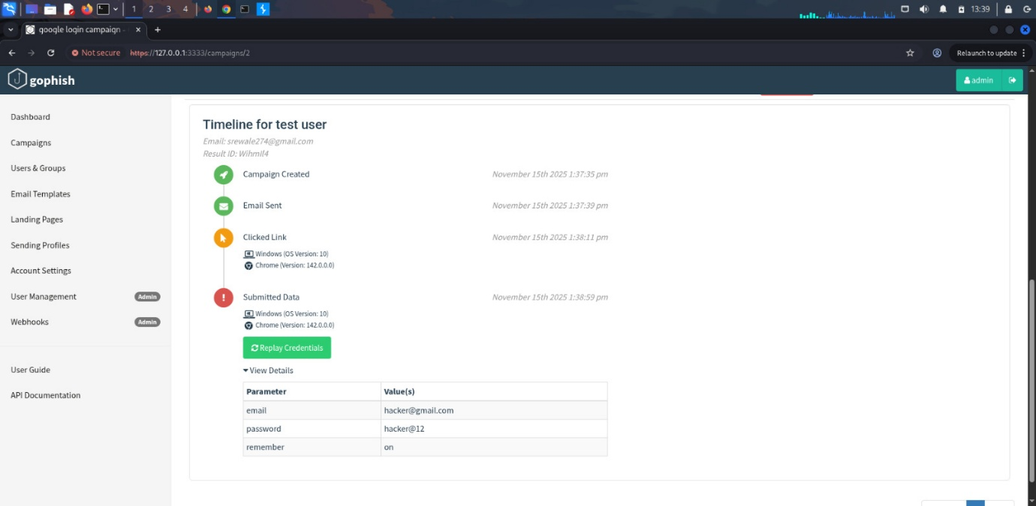

4.3 Overall Campaign Stats
From the results dashboard:
Metric | Count
Emails Sent | 1
Emails Opened | 1
Links Clicked | 1
Credentials Submitted | 1
Reports | 0
Success Rate: 100% (based on single target test case)
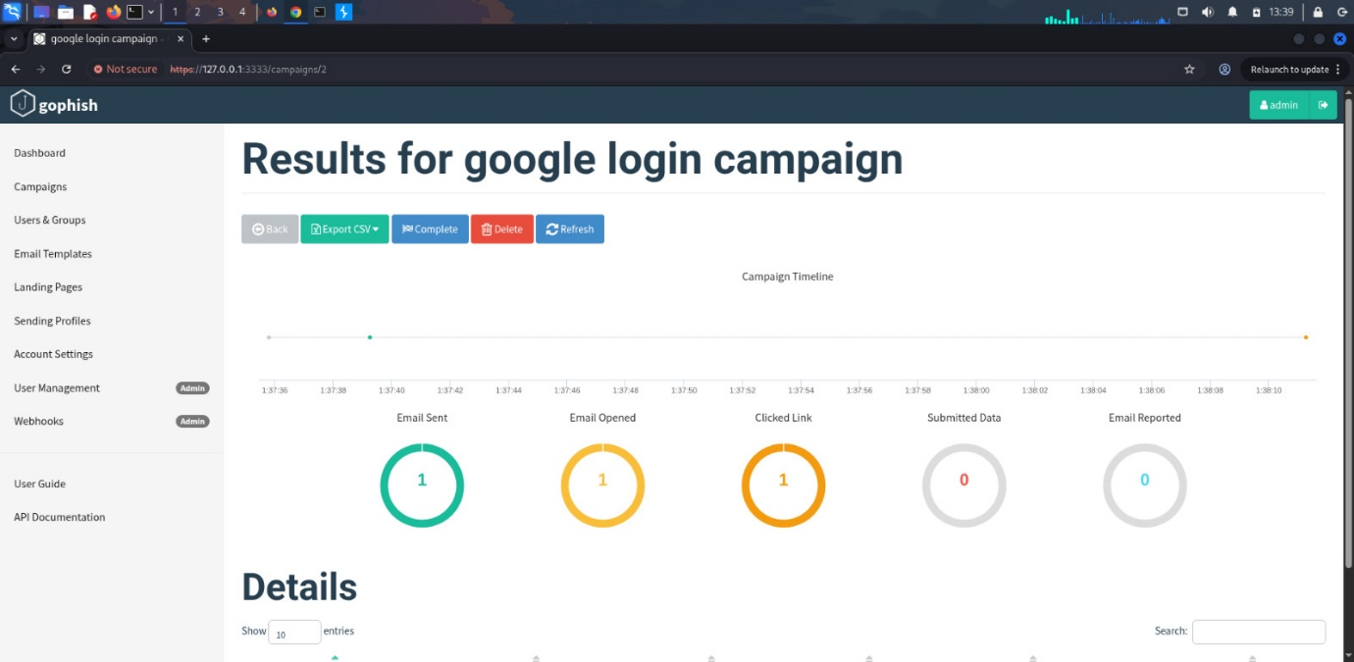

5. Analysis & Observations
5.1 User Behavior
The test user:
- Opened the email
- Clicked the phishing link without suspicion
- Entered and submitted login credentials
This demonstrates high vulnerability to phishing-style attacks.

5.2 Template Effectiveness
The Google-branded email and landing page were highly convincing.
No SPF/DKIM/DMARC rejection occurred due to Postfix handling mail delivery locally.
5.3 Logging & Tracking
GoPhish successfully tracked:
- OS and browser of the user
- Timestamp of each event
- Credential submission
This confirms the infrastructure was correctly set up.

6. Recommendations
6.1 For Users
- Be cautious of emails prompting urgent account security action
- Always verify sender domains
- Never enter login details into non-HTTPS or unfamiliar pages
6.2 For Organizations
- Implement strong email filtering and anti-spoofing policies (SPF, DKIM, DMARC)
- Conduct periodic phishing awareness training
- Use multi-factor authentication (MFA) and login alerts
- Monitor for suspicious login attempts

7. Conclusion
The GoPhish campaign successfully simulated a realistic phishing attack.
All components—Kali Linux, GoPhish, and Postfix—functioned correctly, capturing user interactions and credentials.
The results highlight how easily users can fall victim to phishing attempts and emphasize the importance of continuous training and security hardening.

